ECA5403-ELECTROMAGNETIC FILEDS AND WAVES
S.S. Manasvini
1912260424
C0-3
EXPERIMENT 10
Aim
To verify Faraday’s law of electromagnetic induction by determining and plotting the emf induced in a multi-turn loop due to (i) a time-varying magnetic flux density (transformer emf), (ii) conductor motion in a magnetic field (motional emf) and (iii) loop rotation (generator emf), and to confirm the polarity of the induced emf using Lenz’s law.
Test Case (i)
Transformer EMF Induced by a Time-Varying Flux Density
clc;
clear;
N = input('Enter number of turns N: ');
A = input('Enter loop area A (m^2): ');
B0 = input('Enter peak flux density B0 (T): ');
f = input('Enter frequency f (Hz): ');
w = 2*pi*f;
t = linspace(0,2/f,2001);
dt = t(2)-t(1); B = B0*sin(w*t);
flux_link = N*A*B; % flux linkage (Wb-turn) 1500 rpm emf_num = -gradient(flux_link,dt); % emf = -d(lambda)/dt (numerical) emf_th = -N*A*B0*w*cos(w*t); % analytical emf Em = N*A*B0*w;
disp('Peak induced emf (V) =');
disp(Em); disp('RMS induced emf (V) =');
disp(Em/sqrt(2));
dev = max(abs(emf_num(2:end-1)-emf_th(2:end-1)))/Em*100;
disp('Maximum deviation (%) =');
disp(dev); subplot(2,1,1);
plot(t*1e3,flux_link,'LineWidth',2);
grid on; xlabel('Time (ms)');
ylabel('Flux linkage (Wb-turn)');
title('Flux linkage');
subplot(2,1,2);
plot(t*1e3,emf_num,'b',t*1e3,emf_th,'r--','LineWidth',1.5);
grid on;
xlabel('Time (ms)'); y
label('Induced emf (V)');
legend('Numerical','Analytical');
title('Induced emf from Faraday law');
Sample Output:
For N = 100, A = 0.01 m², B0 = 0.5 T and f = 50 Hz, the peak emf = 157.08 V, the rms emf = 111.07 V and the maximum deviation is below 0.001 %.
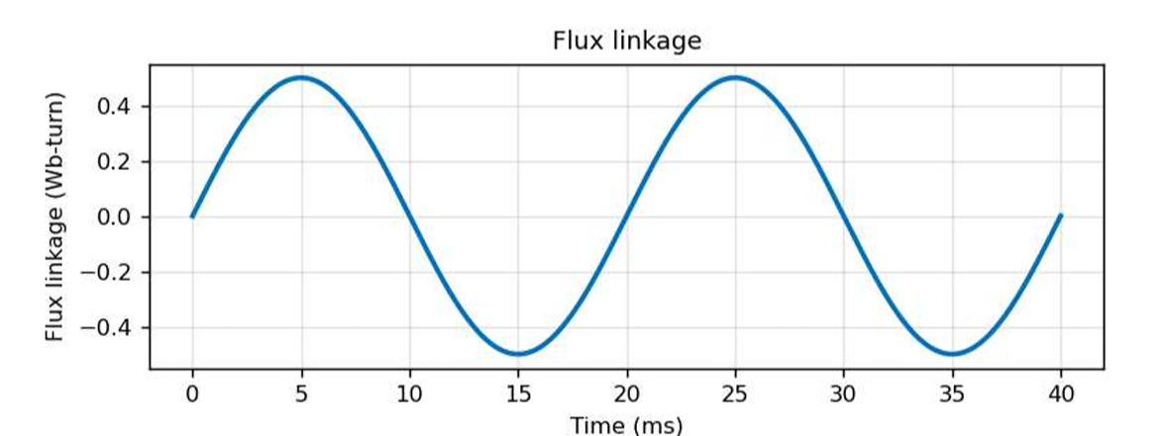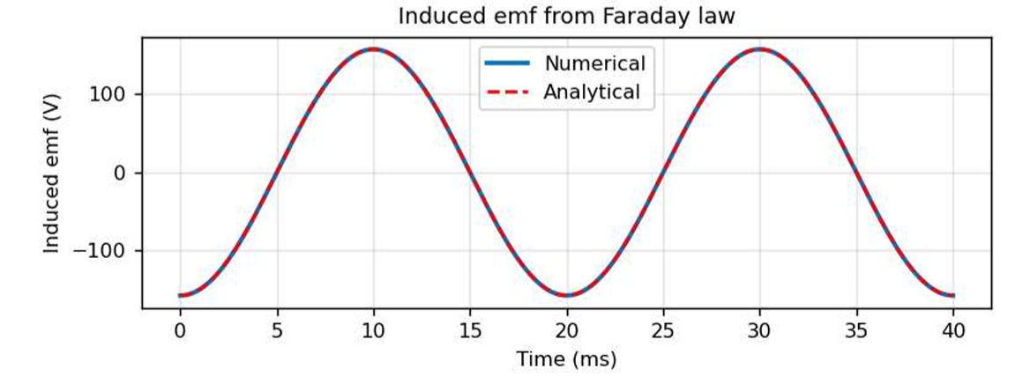

Test Case (ii)
Motional EMF of a Conductor Moving in a Magnetic Field
clc;
clear;
B = input('Enter flux density B (T): ');
l = input('Enter conductor length l (m): ');
u = input('Enter velocity u (m/s): ');
th = input('Enter angle between u and B (deg): ');
emf = B*l*u*sind(th); disp('Motional emf (V) =');
disp(emf);
uv = linspace(0,20,100);
emf_u = B*l*uv*sind(th);
subplot(1,2,1);
plot(uv,emf_u,'LineWidth',2);
grid on;
xlabel('Velocity u (m/s)');
ylabel('Motional emf (V)');
title('emf versus velocity');
thv = linspace(0,180,181);
emf_a = B*l*u*sind(thv);
subplot(1,2,2);
plot(thv,emf_a,'LineWidth',2);
grid on; xlabel('Angle between u and B (deg)');
ylabel('Motional emf (V)'); title('emf versus angle');
Sample Output:
For B = 0.5 T, l = 0.2 m, u = 10 m/s and θ = 90°, the motional emf = 1.00 V; for θ = 30° the emf = 0.50 V.
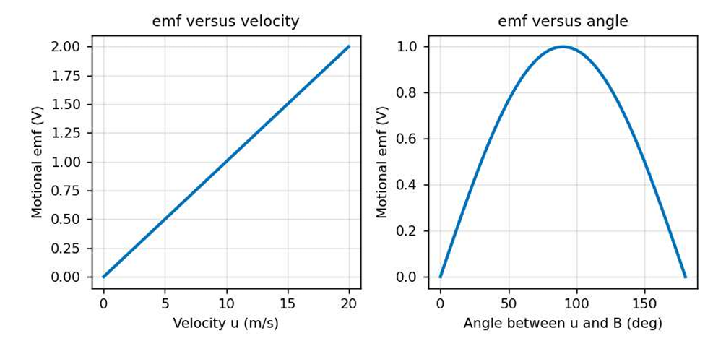

Test Case (iii)
EMF of a Rotating Loop (Generator Action)
clc;
clear;
N = 100;
B = 0.5;
A = 0.01;
rpm = 1500;
w = 2*pi*rpm/60;
f = w/(2*pi);
t = linspace(0,2/f,1000);
emf = N*B*A*w*sin(w*t);
Em = N*B*A*w;
Erms = Em/sqrt(2);
fprintf('Frequency f = %.2f Hz\n', f);
fprintf('Peak emf = %.2f V\n', Em);
fprintf('RMS emf = %.2f V\n', Erms);
plot(t*1e3,emf,'LineWidth',2);
grid on; xlabel('Time (ms)');
ylabel('Induced emf (V)');
title('EMF of a rotating loop');
Sample Output:
For N = 100, B = 0.5 T, A = 0.01 m² and 1500 rpm, f = 25.00 Hz, the peak emf = 78.54 V and the rms emf = 55.54 V.
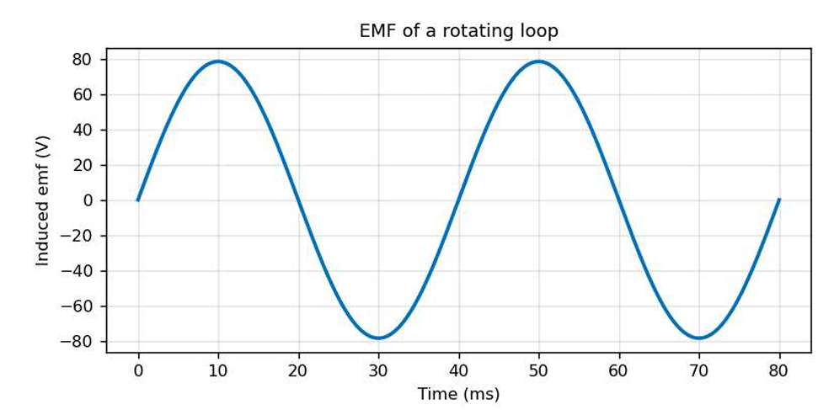

Test Case (iv)
Effect of Frequency and Number of Turns on the Peak EMF
clc;
clear;
A = 0.01;
B0 = 0.5;
f = linspace(10,100,100);
Nv = [50 100 200]; hold on;
for k = 1:3 Em = Nv(k)*A*B0*2*pi*f;
plot(f,Em,'LineWidth',2);
end grid on;
xlabel('Frequency f (Hz)');
ylabel('Peak induced emf (V)');
title('Peak emf versus frequency');
legend('N = 50','N = 100','N = 200');
Sample Output:
At f = 50 Hz the peak emf is 78.54 V for N = 50, 157.08 V for N = 100 and 314.16 V for N = 200; for N = 100 at f = 100 Hz it is 314.16 V.
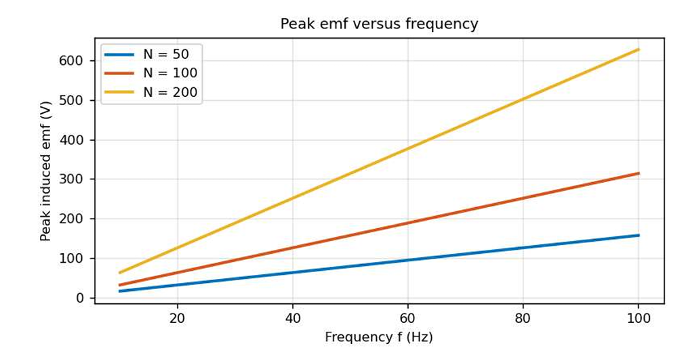
RESULTS:
Thus the Verification of Faraday’s Law of Electromagnetic Induction – Determination and Plotting of Induced EMF (Transformer EMF and Motional EMF) have been done using MATLAB software
S. No. | Objective | Assessment Criterion | Excellent – 4 | Good – 3 | Satisfactory – 2 | Needs Improvement – 1 | Weighting (%) | Marks given | Marks obtained
1 | Identify induction mechanism and parameters | Identify induction mechanism and parameters | Correctly identifies flux change/turns for transformer EMF and B, length, velocity/ orientation for motional EMF. | Identifies most parameters correctly. | Some parameters or directions are unclear. | Uses an incorrect physical model. | 25 | 2.5
2 | Calculate induced EMF in MATLAB | Calculate induced EMF in MATLAB | Implements the applicable Faraday and motional EMF equations correctly with units/sign convention. | Calculations are mostly correct with minor errors. | Some calculations require assistance. | EMF calculations are incorrect. | 25 | 2.5
3 | Plot and verify EMF behaviour | Plot and verify EMF behaviour | Plots expected variation and verifies results against theoretical relations. | Plots and verification are mostly correct. | Plot or validation is incomplete. | No valid plot or verification. | 30 | 3
4 | Interpret and document results | Interpret and document results | Distinguishes transformer and motional EMF and provides clear tables/plots/ conclusion. | Explanation is correct with minor omissions. | Explanation is limited. | Results are not explained or documented. | 20 | 2
Total |  |  |  |  |  |  | 100 | 10

